**MINI PROJECT**

**TEXT BASED ADVENTURE GAME**

1. INTRODUCTION:

* Welcome the player to the Text Adventure Game.
* Sets the initial scenario by describing the player's location as a mysterious place.
* States the player's goal: to reach the treasure room.
* Delays the print statements using **time.sleep(1)** to create a sense of pacing.

1. CHOICE-MAKING FUNCTION:

* Takes a list of options as an argument.
* Prints the options for the player to choose from.
* Prompts the player to enter the number corresponding to their choice.
* Returns the player's choice as an integer.

1. CAVE EXPLORATION FUNCTION:

* Simulates the player entering a dark cave.
* Presents the player with two tunnels to choose from
* Calls the **make_choice** function to get the player's decision.
* If the player chooses the left tunnel, they encounter a giant spider, resulting in a game over.
* If the player chooses the right tunnel, they find a hidden passage and proceed to the next room.

1. FOREST EXPLORATION FUNCTION:

* Simulates the player finding themselves in a dense forest.
* Presents the player with the choice to follow a path or turn back.
* Calls the **make_choice** function to get the player's decision.
* If the player follows the path, they get lost in the forest, leading to a game over.
* If the player turns back, they decide to find their way out, leading to success.

1. TREASURE ROOM FUNCTION:

* Prints a congratulatory message when the player successfully reaches the treasure room.
* Describes the discovery of a chest full of gold, indicating that the player has won the game.

1. MAIN FUNCTION:

* Calls the **introduction** function to set the stage.
* Executes the cave function, followed by the forest function if the player successfully navigates the cave.
* If the player successfully navigates both the cave and forest, they reach the treasure room and win the game.

1. EXECUTION:

* Calls the **main** function to start the game when the script is run.

1. SOURCE CODE:

import time

def introduction():

print("Welcome to the Text Adventure Game!")

time.sleep(1)

print("You find yourself in a mysterious place.")

time.sleep(1)

print("Your goal is to reach the treasure room.")

time.sleep(1)

print("Let the adventure begin!\n")

def make_choice(options):

print("Choose an option:")

for i, option in enumerate(options, start=1):

print(f"{i}. {option}")

choice = int(input("Enter the number of your choice: "))

return choice

def cave():

print("\nYou enter a dark cave.")

time.sleep(1)

print("There are two tunnels in front of you.")

options = ["Go left", "Go right"]

choice = make_choice(options)

if choice == 1:

print("You encounter a giant spider. Game over!")

elif choice == 2:

print("You find a hidden passage and proceed to the next room.")

return True

def forest():

print("\nYou find yourself in a dense forest.")

time.sleep(1)

print("There is a path leading deeper into the forest.")

options = ["Follow the path", "Turn back"]

choice = make_choice(options)

if choice == 1:

print("You get lost in the forest. Game over!")

elif choice == 2:

print("You decide to turn back and find your way out.")

return True

def treasure_room():

print("\nCongratulations! You have reached the treasure room.")

print("You find a chest full of gold. You win!")

def main():

introduction()

if cave():

if forest():

treasure_room()

if __name__ == "__main__":

main()

1. OUTPUT:

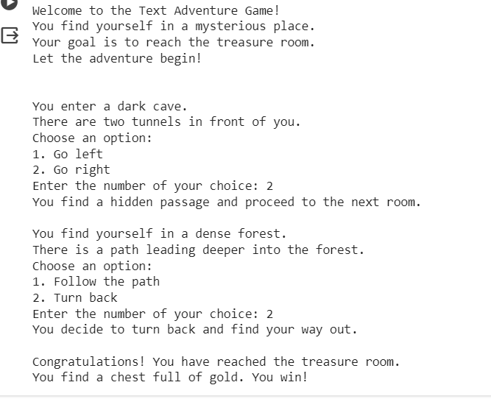

The MINI PROJECT “TEXT BASED ADVENTURE GAME DEVELOPMENT”, submitted by NILOJI SUPRAJA.